ENSF-381:Full Stack Web Development Laboratory

Lab05

Section:02

GitHub Link :<https://github.com/AliHas1212/Esnf381_lab5.git>

Group information:

Ali Hassanein 30140022

Benny Ndabaramiye 30166945

Exercise 2:

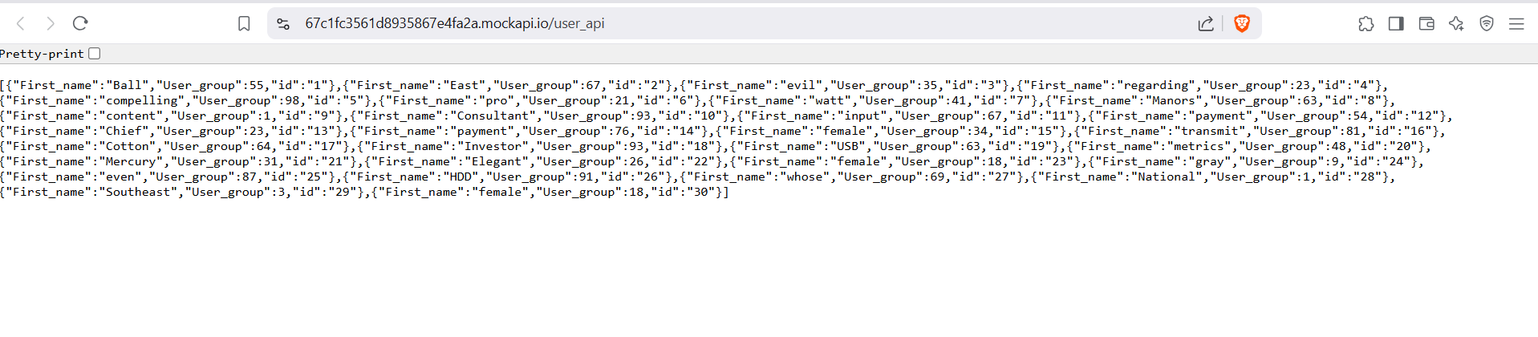

Exercise 3:

